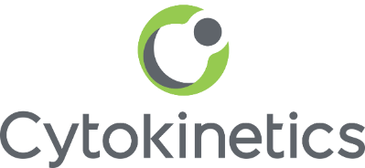

Cytokinetics Communications Fellowship Grant
Program Application

Please complete and email application and attachments to grants@cytokinetics.com.

Name of Organization:

Contact Information
First Name:
Last Name:
Title:
Email Address:
Telephone Number:

Organization Information
Therapeutic Area (please indicate one):

- Neuromuscular (general)
- Amyotrophic Lateral Sclerosis
- Spinal Muscular Atrophy
- Cardiovascular (general)
- Heart Failure
- Hypertrophic Cardiomyopathy

Organization Legal Name:
Address:
Telephone:
Email Address:
Organization Website:
Organization Type:

Mission Statement:

Organization directors and key communications staff:

With your submission please include the following:
- Communications Fellowship Proposal (500 to 1000 words). Please explain the potential impact of the funding and where you see gaps that may be filled, how you would plan to use the funds, proposed outcomes and methods of measuring success.
- Completed W-9 Form
- 501(c)(3) or 501(c)(4) Tax Exempt Statement Form

